上海市“星光计划”
第十届职业院校技能大赛

“英语口语”项目样题

二〇二三年三月

一、中国故事（Speech）模块
本环节为视频参赛。根据抽取的主题，用英文讲中国故事。
（每位选手竞赛时间：3分钟；分值：10分）
工匠精神
Craftsmanship

二、情景交流（Interview）模块
本环节为现场竞赛。
(每位选手竞赛时间：3分钟；备赛时间：8分钟；分值：10分）
Task: Suppose you are working in the City University of Hong Kong, and are talking to an international student, inform and clear any doubts regarding the Chinese calligraphy workshop.
Contestant: An administrative assistant at the City University of Hong Kong
Question Master: An international student
Quantity of Questions: 6-8
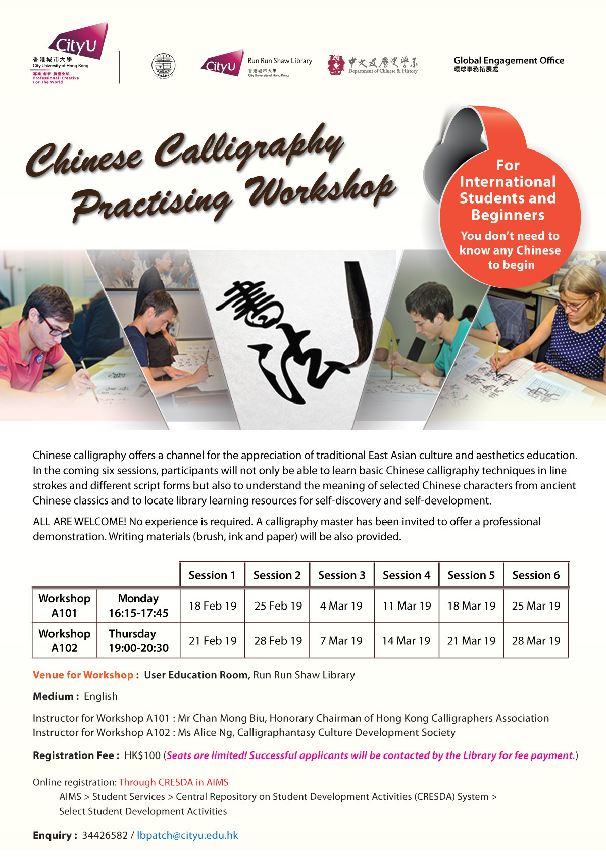
三、职场描述（Presentation）模块
本环节为现场竞赛。
（每位选手竞赛时间：3分钟；备赛时间：8分钟；分值：10分）
Task: You are required to talk about the following illustration. First read and interpret the charts presented in the illustration and then illustrate why our native brands become so popular in 2021.

四、职场辩论（Debate）模块
本环节为现场竞赛。
（每组参赛选手竞赛时间：5分钟；备赛时间：10分钟；分值：10分）
Background: In China, the concept of flexible employment is increasingly favored, particularly by younger people. Fostered through robust development of the internet and technology, freelancers, who are self-employed and earn money on a per-job or per-task basis, usually for short-term work, credit its popularity for their flexible work schedule, work places and a better work-life balance.
Our Question: What do you prefer: working as a freelancer or having a full-time job?
Pro: I prefer to be a freelancer.
Con: I prefer to have a full-time job.

