**上海市“星光计划”**

**第十届中等职业学校职业技能大赛**

**职业英语技能项目决赛样题**

**听读部分（60分）**

**考生注意：请将所有答案写在答题纸上，写在试卷上一律不给分。**

**考试时间为60分钟。**

**Part I Listening**

**Section 1**

**Directions: In this section, you will hear five short sentences. There are three pictures marked A, B, and C for each sentence. Choose the picture that best matches the sentence. Each sentence will be read twice. You will have 10 seconds for each sentence. （10分）**

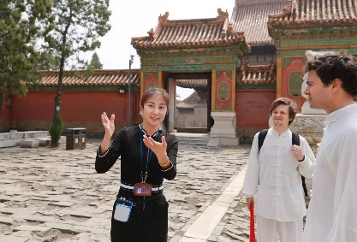1.

A B C

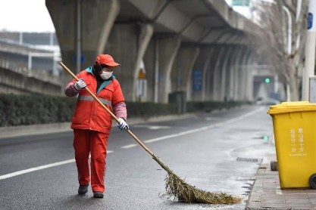2. 

A B C

3.

A B C

4.

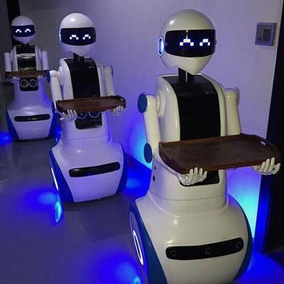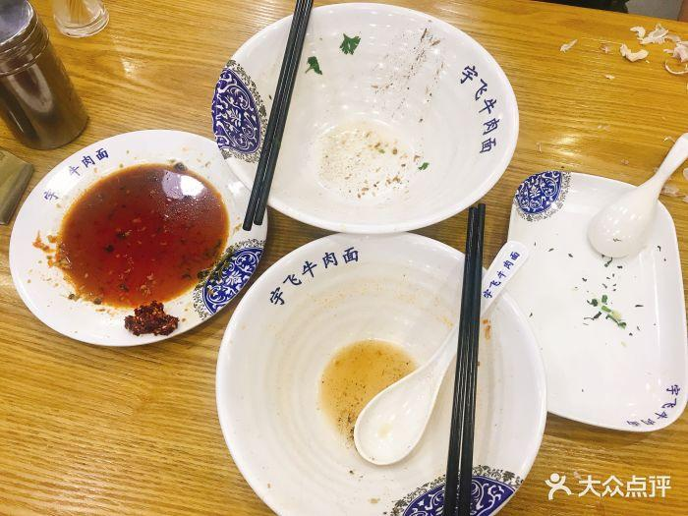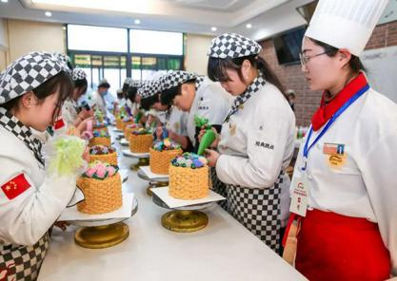 A B C

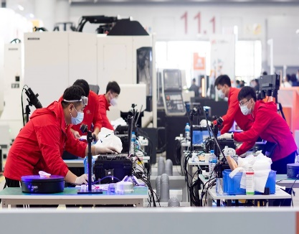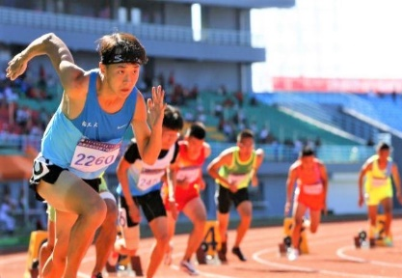5.

A B C

**Section 2**

**Directions: In this section, you will hear a dialogue. Fill in the blanks according to what you hear. The dialogue will be read twice. You will have 1 minute for the task. （10分）**

|  |  |
| --- | --- |
| **Delivery Form** | |
| **Name** | Sally Baker |
| **Delivery Address** | 18 6 Rd.  Bradfield  GT8 2LC |
| **Telephone number** | 7 |
| **Delivery Date** | 12th, November |
| **Delivery Time** | Any time in the 8 |
| **Payment** | 9 |
| **Total Price** | £ 10 |

**Section 3**

**Directions: In this section, you will hear a short passage and 5 questions following the passage. The passage and the questions will be read twice. Choose the best answer according to what you have heard. （10分）**

11. A. Those who have just started a new job.

B. Those who are in charge of a company.

C. Those who’d like to finance a project.

D. Those who are in charge of recruitment.

12. A. 2. B. 3. C. 5. D. 6.

13. A. Stick to what suits yourself.

B. Prepare enough nice and neat clothes.

C. Learn from the way your colleagues dress.

D. Create a dress code for your HR department.

14. A. The later the better.

B. 15 minutes late.

C. 15 minutes early.

D. Just at the end of work time.

15. A. Your conversation with your boss should be brief and precise.

B. Making friends with your colleagues is not considered a necessity.

C. Many bosses look forward to innovative ideas to make a change.

D. Complain to your manager about your dissatisfaction.

**Part II Reading**

**Section 1**

**Directions: In this section, you will read five short texts. There is a question and four possible answers for each text. Choose the best answer for each question. （10分**）

16.

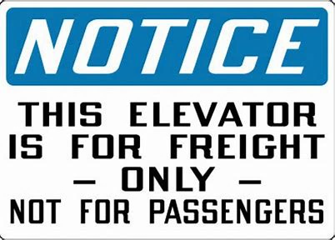

This notice can probably be seen __________.

A. in the school B. at the airport

C. in a bank D. in a gas station

17.

**This note serves as a notice that you have been evicted from the company, effective immediately. Please speak to the manager to begin the process of removing your belongings. Your entry into this building without permission of the manager is a crime, and the police will be called.**

Your will receive this note from HR when __________.

A. you have committed a crime B. you are promoted to a higher position

C. you are dismissed from your job D. your office is going to be refurbished

18.

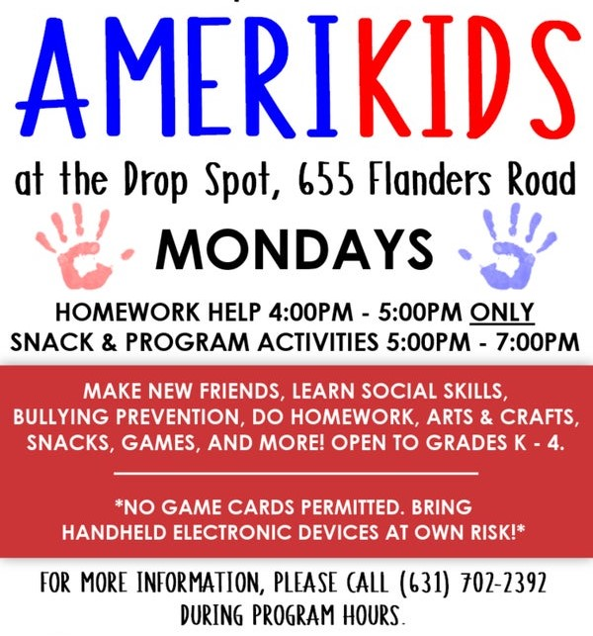

Which of the following is NOT included in the above text?

A. Sponsors of the program. B. Age group.

C. Organized activities. D. Contact information.

19.

Mr. Jones has the responsibility to deal with *Situation* __________.

Situation A: The photocopy machine in the office broke down.

Situation B: A shareholder of the company wants to transfer his shares.

Situation C: One of the staff has asked for a sick leave.

Situation D: The company is planning to reduce cost.

20.

We can infer from the above ad that ______________________.

A. only potential customers are likely to receive this ad

B. the products they sell can help make cooking easier

C. either online or off-line purchase is acceptable and welcome

D. you are encouraged to buy and show small acts of kindness

**Section 2**

**Directions: In this section, you will read five short descriptions and six pieces of information related to them. Match the description and the related information and fill in the brackets with the letters. Notice there is one extra piece of information you do not need. （10分）**

1. The reasons of working abroad
2. Tips on improving your job application
3. Overseas work experience for students
4. A career center for job hunters
5. What makes good staff in the service industry
6. How to reduce your Internet usage

( ) 21. West London employers have a permanent base in the center of West Thames College, with access to a data base of more than 24,000 jobs available locally and in Central London. They will also help you with job applications and interview techniques.

( ) 22. Working abroad has never been more popular. Many students take a gap year before college and work their way around the world, picking fruit in Australia or bartending in Southeast Asia. Also, many developed countries accept foreign guest workers to fill vacancies for all sorts of occupations, with positions for doctors and nurses, child minders, construction workers and waiters.

( ) 23. We’re definitely looking for people who understand the importance of good service. This can often be as simple as greeting guests as they enter. We encourage our staff to anticipate the needs of our guests.

( ) 24. It is amazing that so many applicants do not take the time to adjust their résumé to suit the position. If, for example, you are applying for a marketing position, the recruiter will probably be put off by large amounts of technical information.

( ) 25. Experts recommend fixing some 'offline time' to the day, when you abstain from all things connected to the Internet. Let your friends know in advance that you are taking this step, and can only be contacted by telephone.

**Section 3**

**Directions: In this section, you will read a passage and five questions about it. Choose the best answer for each question. （10分）**

In February 2021, a *NASA* (美国国家航空和宇宙航行局) rover landed on Mars. A rover is a robotic vehicle with wheels. Landing on Mars was a difficult task. In charge of this was Swati Mohan. She is the lead systems engineer for the mission. Mohan has worked on different NASA missions, including the Mars 2020 mission. She has worked on it since 2013.

Mohan was born in India. She moved to the United States when she was a year old. She grew up in the Washington, D.C. area. Then, she studied engineering at Cornell University. Then she got a Ph.D. at the Massachusetts Institute of Technology (MIT).  You can learn more about her below.

**Question: What sparked your interest in space and science?**

**Mohan:** I watched “Star Trek” when I was 9. They were exploring new regions of the universe. I remember thinking “I want to do that. I want to find new and beautiful places in the universe.”

There is so much information we can get from studying space. Most of the information we still have to learn about!

**Question: When you were young, what did you want to become when you grew up?**

**Mohan:** I wanted to become a doctor. Though I was also interested in space. At first, I did not know how to turn that interest into a job. Then I took my first physics class at age 16. I had a great teacher. Everything was so easy to understand. That was when I really considered engineering as a way to follow my passion.

**Question: ___________________________________?**

**Mohan:** I work on a system for the Mars 2020 mission. It is the eyes and ears of the spacecraft.

During the trip to Mars, we needed to do a few important things. We needed its *antennae* (天线) pointed toward the Earth, so that we could communicate with the machine. And, we had to control the spacecraft to get it where we wanted it to go.

Then, we had to land the spacecraft safely. We did that by giving commands to the spacecraft.

**Question: What is your favorite part about working for NASA?**

**Mohan:** Lots of exciting things happen where I work. We are trying to understand more about the universe. It is often something new. I really enjoy it!

26. When was Mohan’s interest in space and science sparked?

A. When she was 1. B. When she was 7.

C. When she was 9. D. When she was 16.

27. In which order did the following event occur to Swati Mohan?

① She worked on the Mars 2020 mission.

② She moved to the United States.

③ She studied engineering at Cornell University.

④ She got a Ph.D. at the Massachusetts Institute of Technology (MIT).

A. ①②④③ B. ②③④① C. ②①④③ D. ③④②①

28. According to the section “Question: When you were young, what did you want to become when you grew up?”, which of the following is **TRUE**?

A. Mohan’s first physics class helped her to become interested in engineering.

B. Mohan’s teacher encouraged her to be an engineer when she grew up.

C. Mohan took her first physics class because engineering was her passion.

D. Mohan dreamed to be a doctor because she thought it would be easy.

29. Which of the following can be filled in the blank in the text?

A. How did you look for a job abroad

B. What do you do in your current job

C. How did you turn your passion into a career

D. What will the future workplace look like

30. What is the best title of the passage?

A. What is the Mars 2020 mission? B. The historical development of NASA

C. How to become an American astronaut? D. Dream Jobs: Mars explorer and engineer

**听读部分考试到此结束。**

**答题纸**

**姓名 考场号 参赛号**

|  |  |  |  |
| --- | --- | --- | --- |
| **大题** | **I 听力** | **II 阅读** | **总分** |
| **得分** |  |  |  |

**Part I Listening Comprehension 听力理解（每小题2分）**

得分

评卷

**Section 1 听句子，选出相应的图片。**

1. 2. 3. 4. 5.

得分

评卷

**Section 2 听对话，完成填空。**

6. 7.

8. 9. 10.

得分

评卷

**Section 3 听短文，选出最佳答案。**

11. 12. 13. 14. 15.

**Part II Reading Comprehension 阅读理解（每小题2分）**

**Section 1 根据短信息，选择最佳答案。**

得分

评卷

16. 17. 18. 19. 20

**Section 2 信息匹配。**

得分

评卷

21. 22. 23. 24. 25.

得分

评卷

**Section 3 根据阅读材料，选择最佳答案。**

26. 27. 28. 29. 30.

**上海市“星光计划”第十届中等职业学校职业技能大赛**

**职业英语技能项目**

口语样题

**情境交流（40分）**

**规则：**

1.选手结对参加比赛。准备时间为十分钟，比赛时间为四分钟；

2. A、B两位选手同时拿到两幅图片，四幅图片合在一起构成一个意义完整、连贯的故事，每位选手的两幅图片内容连贯；

3. A、B两位选手首先在准备室分别独立（隔离）准备，随后两位选手相互交流图片内容及各自的感悟或体会。**本环节两位选手均不得向对方展示图片**（十分钟））；

4. A、B两位选手在比赛室**以会话形式**呈现图片内容和感悟，注意话语量的均衡（两分钟）；

5. A、B两位选手**各自回答评委就图片内容提出的问题**，每人一个问题，回答顺序不限，但不可以替代同伴回答（两分钟）。

**要求：**

1.正确理解图片内容及其蕴含的意义，并阐释个人见解；

2.正确理解评委提出的问题，回答有理有据、言简意赅；

3.语言表达须观点明确，条理清晰，表述自然、流畅、达意；

4.选手比赛时只能用英语表达。

